Plan Guidelines –

Please see Lyn-Genet’s videos on how to make soup EASILY on YouTube

Men increase all portions by 1.5

All sauces are suggested. Please consult with me if you would like to use other seasonings.

Beet carrot salad- grate 4-5 carrots and 1 small beet. Should make 4 servings- stores well in Tupperware for a week. Please dress with lemon and evoo during the cleanse for best liver gall bladder health

Spices: Please include these good digestive/anti-inflammatory spices whenever you would like. You can try most salt-free blends as long as they don’t have paprika or licorice
  - Basil, Black Pepper, Cardamom, Cayenne, Cinnamon, Cumin, Ginger, Rosemary, Turmeric
  - Sea salt – No salt until day 5.
  - Friendly dill or mint you can include: dill, mint, tarragon, rosemary, sage
  - Parsley, cilantro, fresh basil, fresh oregano are tests!

Portions- Unless portions are noted please eat until you are full
- Manchego 1 oz
- Goat’s cheese: 1 oz
- Nuts: unless noted is a handful, which is roughly 1 oz

Carrot ginger soup- our anti-inflammatory soup and freezes very well- please consult with your nutritionist on when it’s best to use. Carrot soup does best when you have a protein rich breakfast like flax or eggs.

Snacks- you may always replace snack that is mentioned with The Plan Trail mix- 1/8th cup sunflower seeds and 1/8th cup dried cranberries, just make sure to rotate

Dessert- chocolate is 1oz and please make sure it’s below 65% and soy lecithin free- good brands are Whole Foods 365 and Taza

Butter- you can add it when it says evoo but please do not sauté with butter unless you use a low heat. Please limit to 1 tbsp a day. Do not have during the cleanse.

EVO- You should be consuming 3-5 tbsp of extra virgin olive oil a day. Why is evoo so important? The brain is 60% fat so we need good fats for cognitive functioning, our cell walls have a phospholipid barrier to we need fat for immune function- evoo is an omega 9 so it acts as a catalyst for anti-inflammatory omega 3 (present in your flax, chia and hemp seeds) and fat keeps you full longer!

Please HYDRATE! Your baseline is half your body weight in ounces - the best way to do this is drink a pint all at once. Please drink water in-between meals, not during as drinking during meals can impair your digestion--If you can leave a 45 window before and after each meal that is ideal.

Finish all water an hour before dinner.

Do not drink water after dinner, even tea

Allow 3-4 hours to digest dinner before bed. Later than 7:30 can be problematic

Supplements
Our standard detox includes MSM, a probiotic and sam-e or lemon balm

If stress tends to lead more to depression, sam-e would be better. Most people do well with 600 mg.

If stress leads more to anxiety or disturbed sleep, then lemon balm would be better. Most people do well with 1500 mg at 5 pm.

Magnesium citrate or constipend is great for occasional constipation, especially after a food reaction.

If you are using MSM and/or sam-e, there often time is no need for additional liver support as they both offer mild liver support.

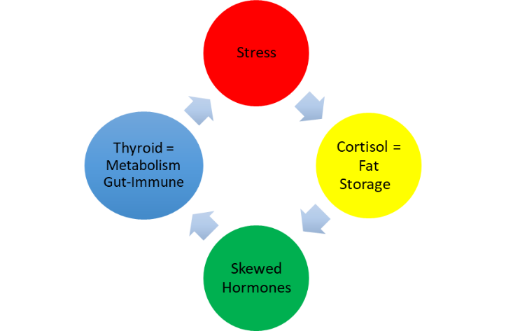

Standard dosages:
- MSM - 6 week course; Standard dosage is based on weight (3,000mg up to 180lbs 4,000mg up to 400lbs 5-6,000mg over 300lbs)
- Probiotics - as needed (when you have a reaction)

General Protein, Food and Testing Information

For more information on general plan guidelines please reference the Intro to The Plan

Protein Ranges women
Breakfast — 10-40 grams of protein
Lunch — 14-16 grams at lunch- more if you are an athlete
Dinner — 25-60 grams of protein (most women do best with 35-45 grams)

Protein Ranges men
Breakfast — 20-60 grams of protein
Lunch — 20-35 grams of protein (stay with 20-25g unless you are an athlete)
Dinner — 35-70 grams of protein

Dense Food Guidelines
1 dense grain carbohydrate a day MAX (rice or bread)
1 animal protein a day MAX
1 bean a day MAX
Grai9ns and starches in the same day is a test
If you want to try more than one serving of these per day you can plug a larger portion in for a test day!

Combination Tests
Rice only does well with fish
Animal protein and eggs or beans is a test
Bread and egg do not play nicely

Good Low Reactive Sources of Protein:
Broccoli- 5 grams per cup- fine chopped
Kale - 6 grams per 2 cups cooked- fine chopped
Sunflower seeds- 6 grams per oz (good source of selenium and calcium)
Pumpkin seeds- 9 grams per oz (great source of zinc for your immune system!)
Almonds- 8 grams per oz
Cheese- 6 grams for soft and 8 grams per hard per oz
Chickpeas- 5 grams per 1/2 cup

Rice – 5 grams per 1 cup

Chia- 5 grams per 2 tbsp (A great source of omega-3’s!)

Cream of Broccoli Soup – 8g per 16oz

The Plan Caesar – 2g per 2 tbsp

Lentils – 1 cup cooked has 18 grams

Raw Cashews – 1 oz has 5 grams of protein

Hemp – 2 tbsp has 7 grams of protein

Peas - 9g per 1 cup

Potatoes – 5g per serving

Flax- 25 grams per 1 cup

Wild Rice – 7g per 1 cup

Spinach- 5g per 1 cup (cooked)

Collards - 6g per 2 cups

Bread- 3-4g per slice

Flour – approximately 13g per cup

Most nuts 5-7g per oz

Eggs – 6g per egg

Buckwheat 24-30 grams a cup

Pumpkin seed hummus- 15 grams per half cup

Tests

Never test when weight is up. Omit the test that day and come back to it later.

Menus- raw and cooked vegetables
In winter we always have either a cooked vegetable or a soup with lunch to aid digestion.

Dinner always has at least two cooked vegetables and a raw veg salad or herbs. Most people do best with 20% salad.

In summer we move to just salads with minimal amounts of cooked vegetables. If you feel that just having a salad makes you feel a little bloated increase the amount of cooked vegetables or add soups back in!

Lettuce
Safe lettuces are baby romaine, boston lettuce, red leaf lettuce, frisee, and small amounts of radicchio. All other lettuces are a test. Any mixed greens blend that has arugula, watercress, tat soi or spinach is a test.

Colder vegetables like romaine and iceberg lettuce will slow weight loss or cause weight gain,do not consume. Run for the hills.

Recipes

Flax Granola
(makes 2-4 servings)

1 cup water
2 cups whole flaxseeds
1 tbsp agave nectar
2 tsp ground cinnamon
1 tsp ground cardamom
1 tsp pure vanilla extract
1/2 tsp nutmeg

Preheat oven to 275F degrees. Combine water and flaxseeds in a medium bowl and mix well. Let sit for at least 30 minutes and mix again. Add agave, cinnamon, cardamom, vanilla extract and nutmeg to flaxseeds and mix thoroughly.

Spread granola in a thin layer on a baking sheet and bake for 50 minutes. Reduce oven temperature to 225F degrees. Cut sheet of granola into clusters, flip and bake an additional 30-40 minutes, until thoroughly dry.
Consume within 2 weeks.

Carrot Ginger Soup
Recipe makes 5 quarts
It can be cut down or many clients love divide into portion out and keep in the freezer!

1 tbsp ground cinnamon
1 tbsp ground cumin
1 tbsp freshly ground black pepper
1 tsp ground cloves
1 tsp cardamom
1/2 tsp turmeric
1/2 tsp allspice
5 quarts water
5lb carrots cut in half
2 large red onions, cut in half
3 large zucchinis, cut in half
8 cloves garlic, peeled
5 to 6 inches fresh ginger
2 tbsp extra virgin olive oil

Combine Cinnamon, cumin, black pepper, cloves, cardamom, turmeric, and allspice in a dry skillet over medium-low heat and cook, stirring constantly, for 30 seconds. IN a large soup pot, combine water, carrots, onions, zucchini, garlic, ginger, and olive oil. Add the rest of the ingredients and simmer for 30-40 minutes.

Puree

Reserve 2 to 4 quarts of the broth for future soup stocks. Transfer remaining soup to a blender in batches and puree.

Note: You can add 1 (14oz can of full fat unsweetened coconut milk and 5 to 6 Vietnamese chili peppers while cooking for a creamier, spicier soup! But not during The Cleanse

Spicy Coco Sauce
This recipe makes 4 to 6 servings (1 1/2 cups); It can either be cut down or frozen for future meals!
Many Planners freeze it in ice cube trays for a quick, flavorful solution for vegetable sautés!

3 tbsp extra virgin olive oil
1 large onion, chopped fine
4 to 5 cloves garlic, minced
2-inch piece fresh ginger, peeled and grated (roughly 1 tbsp)
2 tsp ground cumin
1 tsp ground cinnamon
1 tsp freshly ground black pepper
1 tsp coriander
1/2 tsp allspice
1 (14 oz) can full-fat coconut milk
4 tbsp Sriracha, or more for extra spice
1 tbsp brown sugar
Optional: 1 lemongrass stalk, cut into 1-inch pieces

In a large saucepan, heat olive oil over medium heat. Add onion and garlic and sauté until they start to turn brown. Add ginger, cumin, cinnamon, pepper, coriander, nutmeg, cardamom, and allspice and sauté for 1 minute at low heat, until spices start to smell fragrant. Add coconut milk, Sriracha, brown sugar, and lemongrass, if desired, stirring for 30 seconds. Reduce heat and simmer, stirring for every 5 minutes, for 15 to 20 minutes, so flavors can fully integrate. Remove lemongrass. Serve immediately or let cool and then freeze.

Blueberry Compote
(Makes 3 servings)

- cup blueberries
- cups water
- cup chia seeds
1 tbsp agave
Cinnamon to taste- suggested ½ tsp can add cardamom, nutmeg, cloves too (all great digestives)

Chop the blueberries and let simmer for 8-10 minutes in a pot of water with cinnamon and agave.

Remove pot from heat and add chia seeds, and stir frequently for 2 minutes. You can serve warm or refrigerate. The compote can also be frozen so feel free to make big batches!

Cream of Broccoli Soup

3 tbsp evoo
1 large onion cut in half
1 tbsp dried sage
1 tsp cumin
½ tsp dried celery seed
6 cups water
1can full-fat coconut milk
12 cups broccoli, cut in half
6 cups zucchini, cut in half (about 3 medium zucchini)
1 tbsp Sriracha -optional
Ground black pepper to taste

Sauté onion and spices in 3 tbsp of evoo. Add in all ingredients and cook until vegetables are tender, approximately 25-30 minutes.
Add in avocado, blend and serve! For a less creamy soup, add more water.

Chicken leek soup
1 large white onion, chopped
1/8th cup dried basil
1/2 tsp pink Himalayan sea salt
1 tsp black pepper
1/2 tsp dried sage
3 liters water
1 tsp agave or honey
3 lbs. carrots, chopped
2 large yellow squash, chopped
1 large leek chopped or 2 small
2 chicken thighs with the bone

¼ cup lime juice to finish

Sautee leeks and herbs in evoo. Add all other ingredients to a soup pot, bring to a boil and then let simmer for 45 minutes.
Take out chicken. Portion soup into 16oz containers. Then remove chicken from bone and shred. Add one ounce of shredded chicken to each 16 oz container of soup. This is low reactive and will not test like 2 animal proteins!

The Plan Smoothie
(Makes 1 serving, 10g protein)

1 ripe pear (can use canned)
¼ avocado
¼ cup chia
Rice Dream (RD) or Silk Coconut Milk (SCM)
Option- 1 tsp honey or agave
Option- vanilla extract or cinnamon

Fill Blender with enough RD or SCM to fill to 16 or 20 oz. Blend. Ice is not recommended if you have thyroid dysfunction.

Apple Streusel

Streusel Topping
1 ½ cup almond flour
2 tbsp brown sugar
1 tsp cinnamon
¼ cup avocado oil

Apple Filling
3 apples, cored and chopped into 1/2 inch pieces
1 tbsp brown sugar
1 tsp cinnamon
½ tsp cardamom
¼ tsp cloves
4 eight oz. baking ramekins

Preheat oven to 350.In a small bowl mix all ingredients for streusel topping by hand or with hand mixer.

Bake apple filling for 30 minutes. Remove let cool and add ½ cup almond flour per 16 oz portion

Pumpkin seed “ hummus”
Portion is half cup for lunch, 2 tbsp for snack

4 cups cooked kale
1 cup pumpkin seeds
¼ cup evoo
¼ cup water
Onion powder
Garlic powder
Dash sea salt or coconut aminos**aim for a lower sodium coconut aminos (230mg-270mg per tbsp)
Dash lemon juice

Blend everything together- if you want it less chunky add a little water

Sunflower Tahini
(OR Pumpkin when noted by your nutritionist)

1 cup sunflower seeds
1/4 cup extra virgin olive oil
1/4 cup water
1 garlic clove, peeled- omit with GERD
2 tbsp. Lemon juice
dash sea salt
optional: add more water for creamier tahini

Add all ingredients to a food processor and blend until smooth, about 3 minutes.
Serve immediately, or store and refrigerate up to 5 days.

Plan Caesar

2 cloves garlic, chopped – omit with GERD
¼cup evoo
4 oz goat cheese or half oz parm
2 tbsp lemon juice
2tsp fresh black pepper
2 tbsp fresh dill or basil, optional

Soak garlic cloves in evoo overnight. Add all ingredients to food processor with an S blade and blend until smooth. Add water as needed for lighter dressing.

Spicy Apricot Glaze
Makes 1 cup (approx. 8-10 servings)

1/4 cup apricot jam
1/4 cup water
2 tbsp sriracha or 1 tbsp chipotle powder

Combine all ingredients and blend until smooth.

Basil Escarole Soup- if you can’t find escarole just omit. Many people like to puree this soup and add lemon to each portion, this is especially refreshing in summer served at room temp.

1 large white onion, fine diced

1/8th cup dried basil

1/2 tsp pink Himalayan sea salt

1 tsp black pepper

1/4 cup EVOO

3 liters water

1 tsp agave o

3 lbs. carrots cut in half

10 zucchini cut in half

2 heads escarole

Add all ingredients in a large pot. Simmer for 30 minutes. Puree. Top with lemon or lime juice.

Vegetable Timbale
Makes 6 servings

1 large zucchini
1 yellow squash
1 red onion, peeled
6 cups kale, deveined
2 large carrots
8 shiitake mushrooms
4 to 5 oz goat cheese or half oz parm, crumbled
1 oz shaved parm

Preheat oven to 400F degrees.
Use a mandolin to slice zucchini, onion, kale carrots, and mushrooms as thinly as you can. In an oiled 9-inch baking dish, create layers as for lasagna, layering vegetables and goat cheese or half oz parm in this order: Zucchini, onion, kale, goat cheese or half oz parm, carrots and shiitakes, then top with Manchego. Bake for 30 minutes, until cheese on top is slightly golden.

Day One- Fresh herbs of choice can be tarragon, mint or dill
Please hydrate - your baseline is half your body weight in oz- the best way to do this is drink a pint all at once and please be finished before you have dinner. Please do not drink ANY water after dinner as this hampers digestion and will slow weight loss and repair down.

Please do not drink over this amount, this will affect kidney function and will cause water retention. I know we tend to think more is better, but we definitely find that drinking too much water negatively affects health and weight loss. Your water does include your pint of water in the morning and any teas you drink. Drinking less water means water retention and impaired weight loss.

If you start to feel detox symptoms double strength peppermint tea will often do the trick. If aspirin is part of your protocol then please feel free to take one if you feel a headache coming on. Try to avoid advil or motrin as each pill can cause .2-.4 lb water retention. I find excedrin migraine and bayer to be especially good!

This detox is designedto be as easy as possible (no juice fasts or master cleanse here!) but still sometimes toxic buildup can cause some discomfort. It is better to deal with this now (really!) than later on when dis-ease starts to crop up in a more serious form. I am here for you and know you will rock this! –
Breakfast
1 cup Flax granola with ½ cup blueberries
Coconut milk or rice dream - this will be your breakfast “milk” for the week.

Lunch
16oz of Carrot ginger soup
2 cups of sautéed or steamed broccoli drizzle with orange oil and lemon juice
Baby Romaine with dill or mint and 1 oz sunflower seeds

Snack
1 apple

Dinner
Sautee broccoli, leeks , kale, zucchini, shiitakes, and yellow squash with spicy coco sauce with a handful of sunflower seeds
Grated Carrot and raw grated beet salad with your choice of herbs and handful of pumpkin seeds

Day Two: Almonds
Breakfast
1 cup of Flax with ½ cup blueberries

Lunch
16oz of Carrot ginger soup with 1 oz almond slivers
Baby romaine with, ¼ avocado
1.5 cups of steamed or sautéed broccoli

Snack
1 pear

Dinner
Leftover veggies with 1 cup basmati rice with pumpkin seeds beet/carrot salad with and handful of sunflower seeds

Day Three: Chicken
Breakfast
1 cup Flax with choice of ½ cup blueberries or ½ pear

Lunch
Baby romaine with carrots and a handful of sunflower seeds
16oz of Cream of Broccoli soup

Snack
12-15 almonds

Dinner
½ portion chicken (2-3 oz) with Italian herbs and orange zest on a bed of baby romaine
Oven roasted zucchini, broccoli, carrots, onions, garlic and Italian herb blend

Day Four: Cheese (you may now have one cup of coffee in the morning and wine at
night with or after dinner)
Breakfast
1 cup flax Granola with ½ cup berries, ½ apple or ½ pear

Lunch
Leftover reheated, roasted vegetables on a bed of baby romaine with and handful of pumpkin seeds and 1oz of goat cheese or half oz parm
OR
½ oz parmesan instead of goat cheese

Snack
Carrots with 2 tbsp raw almond butter
** IT MUST SAY RAW ON THE CONTAINER
Or
Plan Trail Mix 1/8th cup sunflower and 1/8th cup craisins

Dinner
4-6oz of Chicken with lemon, garlic and rosemary
Baby Romaine or frisee with carrots and ¼ avocado
Kale with yellow squash, lemon and dill

Day Five: Test Exercise (you may now have dessert and sea salt in moderation)
- beginner 4-6 min ~ intermediate/adv 10-12 min

Breakfast
The Plan Smoothie

Lunch
Red leaf lettuce with radicchio, carrot/beet salad and handful of sunflower seeds
16oz of Cream of Broccoli soup

Snack
Carrots with pumpkin seed hummus
Or
½ apple with raw almond butter

Dinner
4-6oz of Chicken with spicy apricot glaze on a bed of red leaf
Sautéed zucchini with onion or leeks
Salad

Day Six: Protein day
Breakfast
Blueberry Compote

Lunch
Baby romaine with ¼ avocado, and 1 oz goat cheese or half oz parm with almond slivers
lemon basil escarole soup

Snack
½ apple and raw almond butter

Dinner – choose your proteins to test
4-6oz of wild halibut or flounder, steak, lamb, duck
Sauteed vegetables- zucchini, carrrots, onion, radicchio
Salad with beets

Day Seven: Test Exercise
- beginner 4-6 min – intermediate/adv 10-12 min
Breakfast
Flax Granola with ½ cup berries, ½ apple or ½ pear

Lunch
Leftover vegetables on a bed of red leaf with handful of pumpkin seeds
Chicken leek soup

Snack
1 oz salt free potato chips

Dinner
Chicken with dill and lemon
Sautéed vegetables- kale, carrots, zucchini, with garlic
Frisee or baby romaine salad

Day Eight: Test New protein
Breakfast
The Plan Smoothie

Lunch
Salad with beets, 1oz of goat cheese or half oz parm and pumpkin seeds
Basil escarole soup

Snack
Carrots with 2 tbsp raw almond butter
Or
Pumpkin seeds

Dinner
Test 4-6oz of a new protein on a bed of red leaf or frisee
Roasted, Sautéed, Grilled or steamed vegetables that have been approved

Day Nine: Test Exercise
- beginner 4-6 min~ intermediate 10-12 min ~ advanced 15 min
Breakfast
Apple Streusel
Or
Blueberry compote

Lunch
Baby Romaine with ¼ avocado and grated carrots
1.5 cups Roasted broccoli with leftover veg and 1.5 oz of goat cheese or 3/4 oz parm

Snack
Pumpkin seeds
Or
Plan Trail Mix

Dinner
Chicken
Baby Romaine with grated raw beet
Sautéed zucchini and leeks

Day Ten: Test new protein
Breakfast
Plan smooothie

Lunch
Chicken Leek soup
salad with 1/2 apple with carrots and a dipping sauce of pumpkin seed tahini

Snack
Mashed avo with lemon or lime

Dinner
Test New Protein
Sautéed yellow squash with onion, basil and fresh lime
Any lettuce used thus far with ¼ avocado and dill or mint such as dill or mint

OR

Test 2 eggs with zoodles and ½ cup pumpkin seed hummus
Salad

Day Eleven: Test increased exercise time by 20%
Breakfast
Blueberry Compote
Or
Smoothie

Lunch
Lettuce of choice with grated carrot, ¼ avocado, 1oz goat cheese and dried cranberries
Chicken Kale Soup

Snack
Toasted pumpkin seeds and ½ apple

Dinner
Any approved protein
Zucchini noodles with onions and garlic
Any lettuce used thus far with ¼ apple and dill or mint

Day Twelve: Test new vegetable
Breakfast
The Plan Smoothie
Or
Blueberry Compote

Lunch
1.5 cups Roasted Broccoli with Plan Caesar
Salad with ¼ avocado and sunflower seeds

Snack
Carrots and 2-4tbsp Pumpkin “ hummus”
Or
Carrots and raw almond butter

Dinner
Approved protein
Test new vegetable mixed with other approved vegetables- use herbs of choice
Any lettuce used thus far with dill or mint and raw grated beet

Day Thirteen: Test increased exercise time by 20%
Breakfast
Flax granola with ½ cup approved fruit

Lunch
Leftover vegetables with almond slivers, ¼ chopped apple on a bed of red leaf lettuce
Chicken Leek Soup

Snack
Pumpkin seeds
Or
Low Sodium Potato Chips

Dinner
Approved protein
Any lettuce used thus far with dill or mint and optional radicchio
1 cup vegetable timbale- 1 cup sautéed yellow squash

Day Fourteen: Optional test bread
Breakfast
Test bread and almond butter
or
Bread and blueberry compote jam
Or
Compote

Lunch
zoodles with ¼ cup pumpkin seeds hummus
Salad with beets and 1.5 oz goat cheese

Snack
Mashed avo “guacamole” with ;lime juice

Dinner
Approved protein
Roasted, Sautéed or Grilled Vegetables that have been approved
Any approved lettuce with dill or mint

Day Fifteen: Test increased exercise time by 20%
Breakfast
Flax Granola with 1/2pear

Lunch
Cream of Broccoli soup
Salad with carrots and sun seeds

Snack
Low Sodium Potato chips
Or
Apple

Dinner
Chicken with spices of choice
Sautéed kale with onions and zucchini and new approved vegetable
Any approved lettuce with dill or mint

Day Sixteen: Test new lunch

Breakfast
Blueberry Compote
Or Streusel

Lunch
1 cup Wild rice with Chicken leek soup
Salad with avo

Snack
Toasted pumpkin seeds
Or
Potato chips

Dinner
Approved protein
Steamed, Grilled or sautéed approved vegetables
Any approved lettuce with dill or mint and grated carrots

Day Seventeen: Test exercise up to 30 minutes
Start working on your menus for days 21-25
Breakfast
Flax granola with ½ portion fruit

Lunch
Create a lunch with 14-16 grams of protein for women
Men create a lunch with 20-25 grams protein

You can use examples from prior days

Snack
Any Approved Snack

Dinner
Approved protein
Sautéed yellow squash, leeks and new veg
Any approved lettuce with herbs of choice

Day Eighteen: Test new fruit or new restaurant
Breakfast
Blueberry compote

Lunch
Create a lunch with 14-16 grams of protein for women
Men create a lunch with 20-25 grams protein

You can use examples from prior days

Snack
1 oz low sodium or no salt potato chips with 1/8th cup homemade guacamole
Or
Test new fruit

Dinner
Test restaurant if did not test fruit

Day Nineteen: Test Exercise up to 30 minutes
Start working on your menus for days 21-25
Repeat favorite day thus far with most weight loss

Day Twenty: No Test
Repeat favorite day thus far with most weight loss

Phase 2: Making Choices

Please create your own menu using this template as a guideline, e-mail it back to your nutritionist to review with you and put in your file.

Optimal Rotation of Protein
chicken 3x a week- every other day
lamb - 3x a week- every other day
eggs- 3 x a week every other day
beans- 3x a week- do not have more than once daily
duck breast- 2-3x a week every other day
fish and seafood - 2 x a week 3 days apart
pork- 1-2 x a week
steak 1x a week
veal- VERY high reactive

Vegetable Rotation
Program your meals so that you do not repeat vegetables. For example, if you have broccoli at lunch, do not have broccoli at dinner, or the next day. Try to always have at least 2 cooked vegetables with your dinners.

Seeds
Try to start programming seed free lunches and dinner or test alternate seeds and nuts

Testing New Lunch Options
You can test ½ cup of lentils and 2 cups cooked kale (15 grams). An fyi beans and broccoli is a test as it can cause too much gas in some people. We try to, at this point, start having seed free lunches and dinners to give your body optimal rotation.

Peas are another vegetable I like people to test at lunch only- 1/2 cup is 4.5 grams of protein and could replace broccoli or sunflower. If you are very active, testing rice would be good on your workout days as a breakfast or lunch option. Rice and fish in the same day is an easy pass- rice and other animal protein in the same day is a harder test to pass.

Wild rice is a good test too with a 1 cup is 7 grams of protein. Wild rice is very low starch so it is often easier to have on days you have animal protein.

Bacon low reactive, weird I know
Spinach is only once a week but it’s a good protein source with 5 grams of protein

Portions
All the portions we use on the plan are the least reactive amounts. If you would like to use larger portions please test them first. Nuts and seeds should be 1 oz per portion, 1.5 for men. Only consume the seed once during the day ex: if you have sunflower seeds at breakfast do not have a seed at lunch or dinner

Natural Sugars —
Most people do well with moderating their intake of natural sugars such as fruit, potatoes, sweet potatoes and winter squashes. Roasted vegetables fall into this category as well, as the natural sugars are increased when cooked for a long period of time. Find your own balance by starting off with roasted veggies twice a week.

Now that you have passed your 20 days please limit your orange vegetables- carrots, butternut squash etc to once a day. More than that is a test and would do better on a day you work out.
After 30 days limit to every other day.

Carrot Ginger soup does best after a high protein, low sugar breakfast like flax.

Combination Tests
Two animal proteins in the same meal is a test.
Beans and meat are a test. Bread and animal protein is ok. Eggs and bread are a test.

Bread and potatoes do well with animal protein (with the exception of eggs) and the pairing of potatoes and animal protein is not a test. Grains, like bread, and a starch like potatoes or peas in the same day works better if you are an athlete.

Rice is a high reactive test with most proteins (even in different meals) including beans, with the exception of fish and seafood which is a lower reactive test. Wild rice is a low reactive test.

Coconut Milk and animal proteins are a test. Coconut milk and fish or seafood is a low reactive test. Coconut Milk and animal proteins are a test.

In winter we always have either a cooked vegetable or a soup with lunch to aid digestion. Dinner always has two different cooked vegetables (at least 2 cups women, 3 cups men) and a raw component . It does not have to be lettuce, it can be avocado, carrots, beets or approved herbs.

Cooked vegetables aid digestion, just eating raw vegetables will hamper digestion. When you hamper digestion, you will experience weight gain or weight stabilization.

Make sure after day 30, that every food is every other day max.

Time to get started!
- Create a list of all the foods that have worked for you
- Create a list of foods that are mildly inflammatory and please limit their usage to once every 7-10 day and always follow with a friendly day
- Retest all foods that tested as inflammatory in 3-6 months. You may be able to reduce sensitivity to this food and have on occasion, always follow with a friendly day

Women Protein Ranges
Breakfast — 10-40 grams of protein (stay at lower end range unless you are an athlete)

Lunch — 15-25 grams of protein (stay at lower end range unless you are an athlete)

Dinner — 25-60 grams of protein

Men Protein Ranges
Breakfast — 15-60 grams of protein (use higher numbers if you are an athlete)
Lunch — 20-35 grams of protein (use higher numbers if you are an athlete)
Dinner — 40-70 grams of protein

Dense Food Guidelines
1 dense grain carbohydrate a day MAX (rice or bread)- more is a test
1 animal protein a day MAX- more is a test
1 bean a day MAX- more is a test
W: fruit maxes out at 1.5 portions a day
M: fruit maxes out at 2.5 portions a day

Day 1 (No test)

Using the outline below, create a menu using your friendly foods.

Breakfast
Easy sources of protein are flax, seeds, nuts and nut butters, grain cereals, milk
Have with fruit

Lunch
W:Create a salad with 14-16 grams of protein
M: create a salad with 20-35 grams of protein
In winter add a soup or cooked vegetable to enhance digestion

Snack
Insert your favorite snack

Dinner
Approved protein
Approved salad
Approved cooked vegetables

Day 2 (Test Exercise or Test New Vegetable)
Using the outline below, create a friendly menu (or use your favorite friendly day thus far) but test exercise as the new variable

Breakfast
Easy sources of protein are flax, seeds, nuts and nut butters, grain cereals, milk
Have with fruit

Lunch
W:Create a salad with 14-16 grams of protein
M: create a salad with 20-35 grams of protein

In winter add a soup or cooked vegetable to enhance digestion

Snack
Insert your favorite snack

Dinner
Approved protein
Approved salad
Approved cooked vegetables

Day 3 (No test)
Follow the guidelines of Day 1 to create another friendly menu.

Day 4 (Test new breakfast item)
Using the outline below, create a friendly menu but test a new breakfast item. Ideas are whole or lactose free milk, eggs or new fruit.
In winter we always have either a cooked vegetable or a soup with lunch to aid digestion. Dinner always has cooked vegetables and a raw veg salad as raw vegetables contain enzymes.

Breakfast
Easy sources of protein are flax, seeds, nuts and nut butters, grain cereals, milk
Have with ½ piece of fruit

Lunch
W:Create a salad with 14-16 grams of protein
M: create a salad with 20-35 grams of protein

Snack
Insert your favorite snack

Dinner
Approved protein
Approved salad
Approved cooked vegetables

Day 5 (No test)
Follow the guidelines of Day 1 to create another friendly menu.

Reactive Food Negative Feedback Loop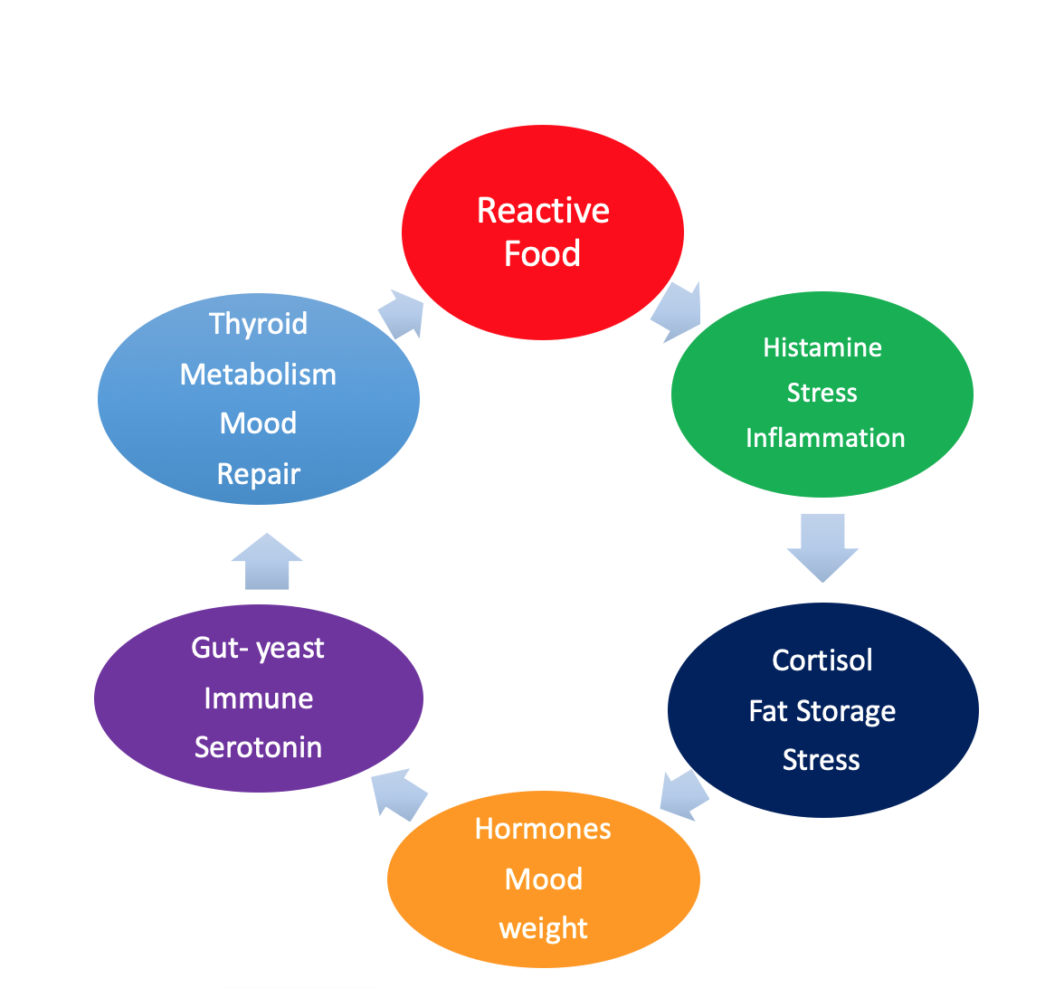

Over-Exercise Negative Feedback Loop

